Technical Report Analysis: Formula 1 Career & Circuit Performance Analytics.

# 1. Introduction

This technical report presents a comprehensive analysis of historical Formula 1 (F1) racing data covering drivers, teams (constructors), circuits, and performance outcomes. The goal is to help stakeholders across the motorsport industry, team managers, sponsors, analysts, and fans to gain data-driven insights to make informed decisions and appreciate the sport’s rich history.

The analysis explores the relationships between circuits, countries, driver nationality, race outcomes, and team success. It highlights the importance of strategy, geography, and legacy in shaping F1’s evolution.

# 2. Story of the Data

The dataset includes a wide array of metrics that track the dynamics of F1 races globally. These features include:

Independent Variables:  
- Circuit details: CircuitRef, CircuitId, Location, Country, Latitude (lat), Longitude (lng), Altitude (alt)  
- Team and driver details: Constructors, ConstructorId, DriverId, DriverRef, Number, Code, Forename, Surname, DOB, Nationality  
- Race details: Year, Date, Grand Prix

Dependent Variables:  
- Points: Driver performance outcome  
- Status: Final race result (e.g., Finished, DNF - Did Not Finish)  
- RaceId: Unique reference combining race and performance

The dataset spans multiple decades and provides insights into driver success, constructor dominance, race locations, and status trends.

# 3. Pre-Analysis

The dataset was cleaned and examined to validate structure and identify trends. Key assumptions made:

- Points earned and race status reflect performance quality.  
- Geography influences driver representation and circuit distribution.  
- Constructor and driver IDs can be linked over time to show historical trends.

Initial data checks confirmed:  
- 73 unique circuits across 32 countries.  
- Thousands of races spanning decades.  
- Consistent patterns in driver nationality, team success, and circuit hosting.

# 4. In-Analysis Observations

- Lewis Hamilton leads all drivers in historical points, indicating unmatched consistency and team synergy.  
- Ferrari has the highest constructor points, reflecting long-term dominance.  
- Most races are held in Europe, showing regional imbalance.  
- Top drivers (e.g., Alonso, Schumacher) often share traits: European nationality, early starts, long careers.  
- British Grand Prix has the highest driver count (407), proving its popularity and importance.  
- Circuits like Monza and Silverstone are central to F1 strategy development.

# 5. Post-Analysis Insights

- Sustained performance matters more than one-time wins; longevity adds value.  
- European countries are overrepresented in circuit hosting and driver nationalities.  
- Constructor success ties closely with legacy, infrastructure, and innovation (e.g., Ferrari vs. Mercedes).  
- Circuit characteristics (altitude, lap speed) directly influence tyre strategy and safety.  
- Global branding doesn’t yet reflect equal global hosting. Africa and Oceania are largely underrepresented.

# 6. Recommendations and Observations

- Teams : Analyze top driver traits to improve talent scouting and team placement.  
- Organizers : Add circuits in Africa, Southeast Asia, and Oceania for global equity.  
- Sponsors: Invest in data-backed top drivers (e.g., Hamilton, Alonso) for high brand visibility.  
- Analysts: Build strategies using circuit-specific metrics like lap speed, pit stops, and weather.  
- FIA: Use DNF and race status data to enhance safety standards and regulate design accordingly.

Insights support more data-driven decisions across all areas of F1, from race strategy to business sponsorship.

# 7. Visualization

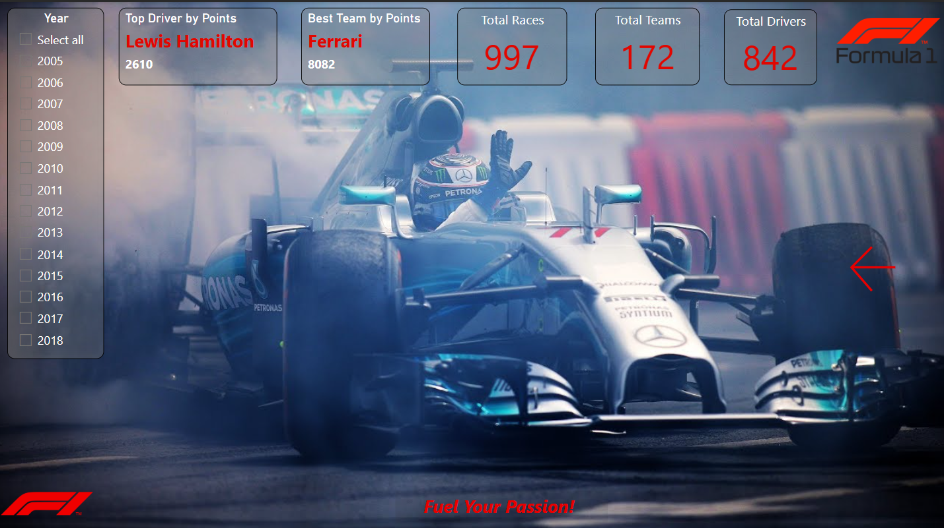

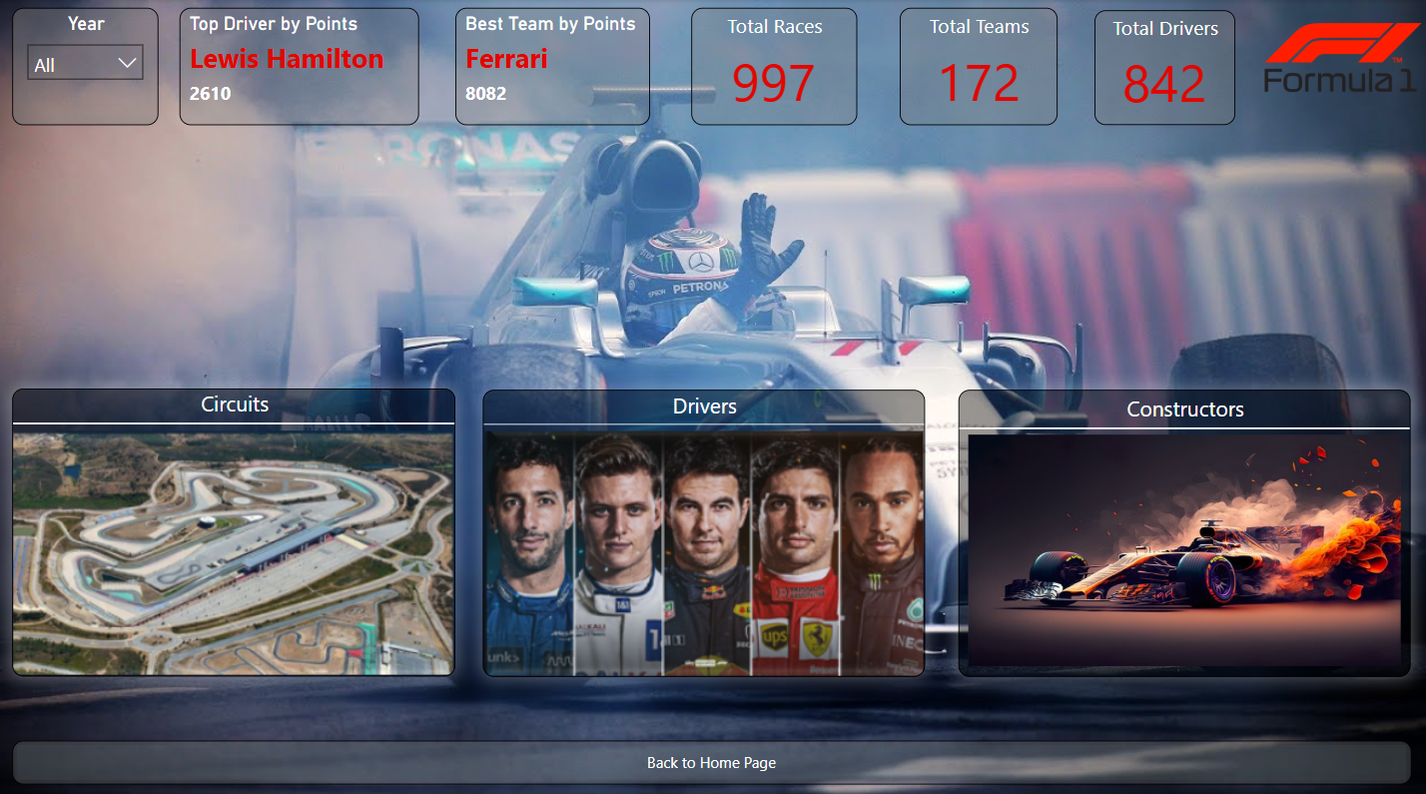

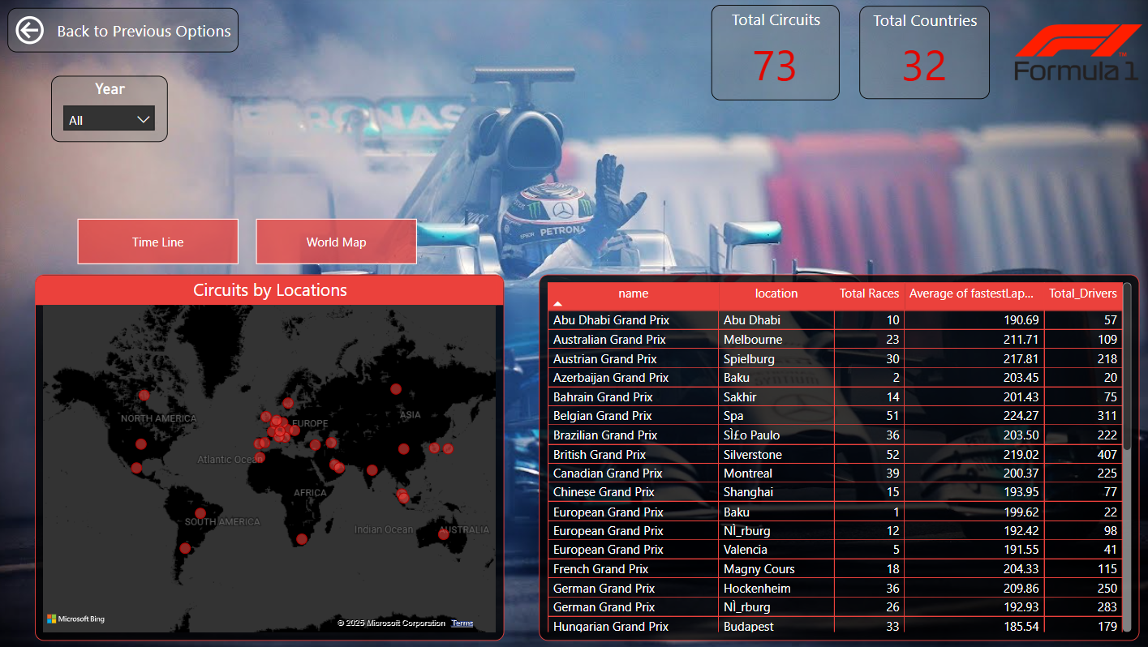

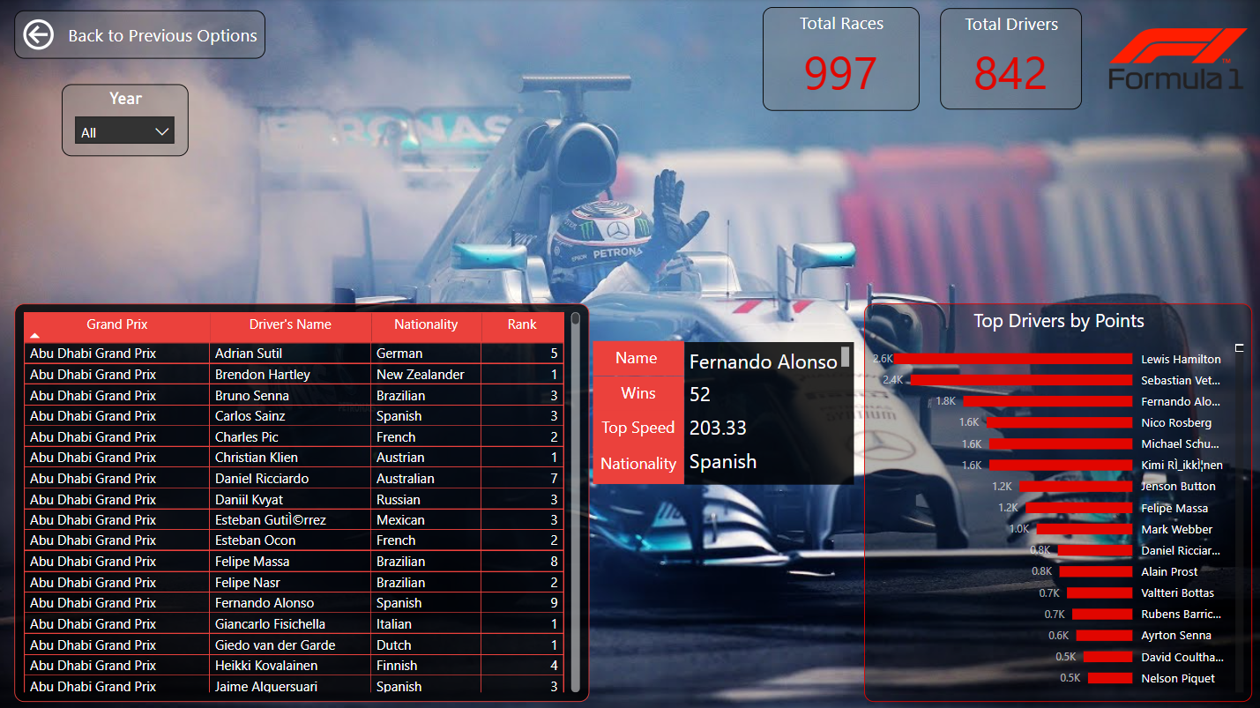

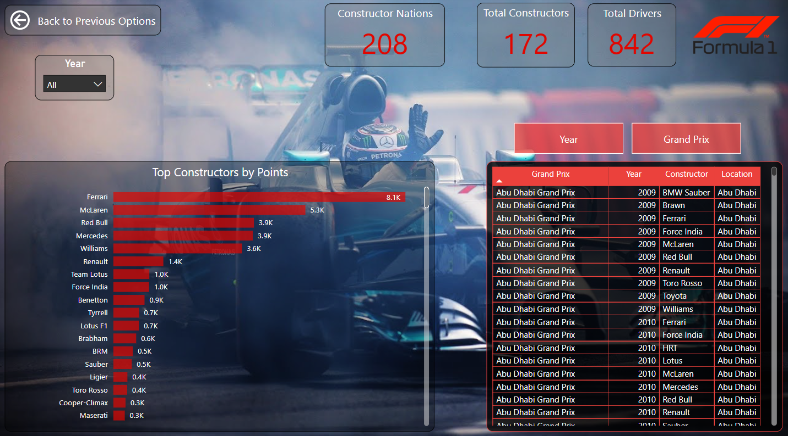

F1 Circuit and Performance Analysis on PowerBi

# 8. Final Observation

Lewis Hamilton remains the standout performer in F1 history, not only in points but in career longevity. His career reflects modern greatness shaped by technology, support systems, and team excellence.

Legacy teams like Ferrari remain dominant, but rising teams (e.g., Red Bull, Mercedes) show how innovation can change the competitive landscape. While European influence persists, there's an opportunity to truly globalize the sport.

Track performance isn’t only about drivers, it’s also about circuit geography, weather, and design. Altitude and climate continue to impact car design and race planning. Data has shifted F1 from a mechanical competition to a tech-driven, strategic ecosystem.

# 9. Final Recommendations

- Use historical data to build predictive race models combining weather, driver performance, and lap history.  
- Identify upcoming driver potential based on attributes of past champions.  
- Develop circuit-specific race plans, including altitude, pit stop frequency, and average lap time.  
- Introduce more non-European circuits to diversify talent pools and improve global branding.  
- Support lower-tier teams with analytical tools to reduce the competitive gap.  
- Focus sponsorship on performance metrics rather than fame alone.  
- Offer fan-focused dashboards tracking rivalries, driver stats, and real-time race data.  
- Provide pre-race “data digest” dashboards showing past winners, weather trends, and circuit traits.

Formula 1 is now driven as much by insights as by engines. This technical analysis equips all stakeholders with tools to excel in an increasingly competitive and global sport.